Single Line Diagram of AC Distribution System in MATLAB Simulink

Block Diagram:
Fig-1: Single Line Diagram of AC Distribution System

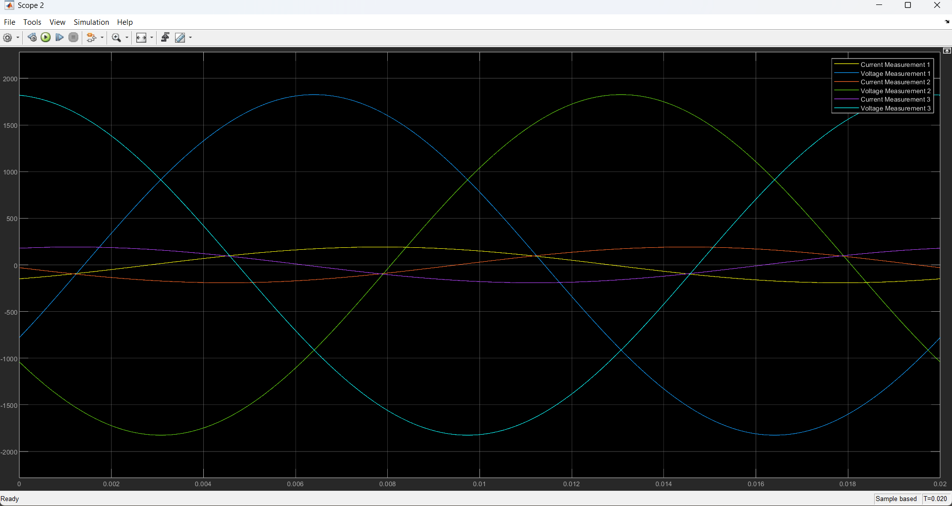
OUTPUT:
Fig-2: Output waveshape of three single-phase loads

